|  |  |  |  |  |
| --- | --- | --- | --- | --- |
| **National University of Computer and Emerging Sciences, Lahore Campus** | | | | |
| C:\Users\saif\AppData\Local\Microsoft\Windows\Temporary Internet Files\Content.Word\final design.jpg | **Course Name:** | **Software Design & Analysis** | **Course Code:** | **CS3004** |
| **Program:** | **BS (CS)** | **Semester:** | **Fall 2021** |
| **Duration:** | **One hour** | **Total Marks:** | **30** |
| **Paper Date:** | **03 Dec 2021** | **Weight:** |  |
| **Section:** | **All sections** | **Page(s):** | **3** |
| **Exam Type:** | **Mid-2** |  |  |
| **Name:____________________________________ Roll No._____________________ Sec: ______** | | | | |

**Question 1**

Consider the following class diagram:



Each gift pack contains a stationary item, a toy, and multiple snacks. The total price depends upon the individual items included in a pack. Give a sequence diagram showing this computation.

Solution



**Question 2**

Draw UML [activity diagram](https://www.uml-diagrams.org/activity-diagrams.html) describing behavior of the [Purchase Ticket use case](https://www.uml-diagrams.org/ticket-vending-machine-use-case-diagram-example.html).

Activity is started by Commuter [actor](https://www.uml-diagrams.org/use-case-actor.html) who needs to buy a ticket. Ticket vending machine will request for verification. Commuter will scan both thumb and face at the same time. Vending machine will perform both biometric and face verification to identify commuter. Once verification will be done, ticket vending machine will request trip information from Commuter. This information will include number and type of tickets, e.g. whether it is a monthly pass, one way or round ticket, route number, destination or zone number, etc.

Based on the provided trip info ticket vending machine will calculate payment due and request payment options. Those options include payment by cash, or by credit or debit card. If payment by card is selected by Commuter, Bank will authorize the payment. After payment is complete, ticket is dispensed to the Commuter. Cash payment might result in some change due, so the change is dispensed to the Commuter in this case. Ticket vending machine will show some "Thank You" screen at the end of the activity.

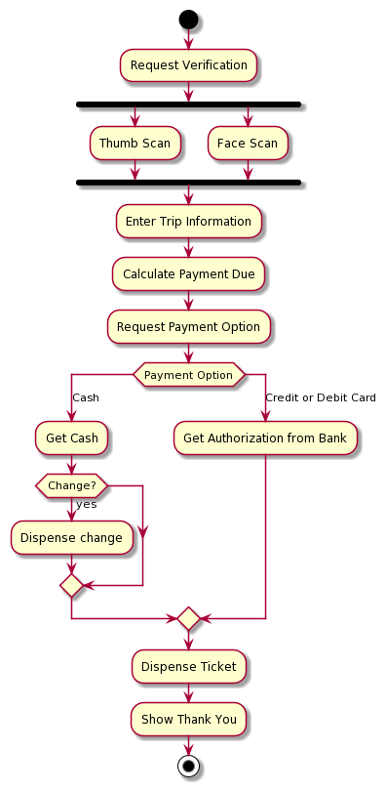

**Question 3**

You have to design a candidate evaluation system with following five modules

1. A module for **MCQ** questions
2. A module for **Programming** problems
3. A **core** module that calculates a final score of the candidate after considering both MCQ and Programming Problems. It also provides required data to the user interface module for presentation.
4. A module that stores results in a **database**
5. A module that implements front end as **web** UI

Your design should conform to the SOLID principles. That means proper dependencies between modules e.g., core module must not depend upon any other module. The design should be open for extension for example to allow adding additional modules for MCQ and Programming Problems. Also, it should allow for adding more front ends e.g., mobile APP in addition to Web.

Clearly show boundaries of all five modules.

Just show one concrete class in each module that contains the logic for that module.

You must show all the required interfaces in appropriate modules.

Show all relationships between classes and interfaces in the system.

**Solution**

